Q1 – Photo
Remember: describe AND give your opinion. PRESENT TENSE ONLY.
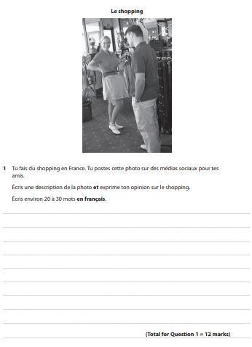
Q2 – 40-50 words
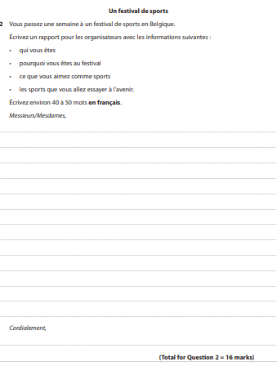
Remember: present x3, future x1.
Q3 – 80-90 words
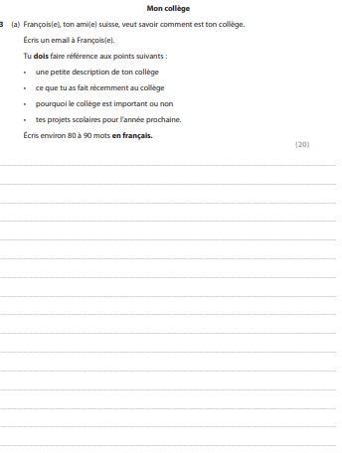
Remember: present x2, past x1, future x1. CHOOSE EITHER A OR B.

Q4 – Translation into French
Remember: write full sentences, even if you’re substituting words
